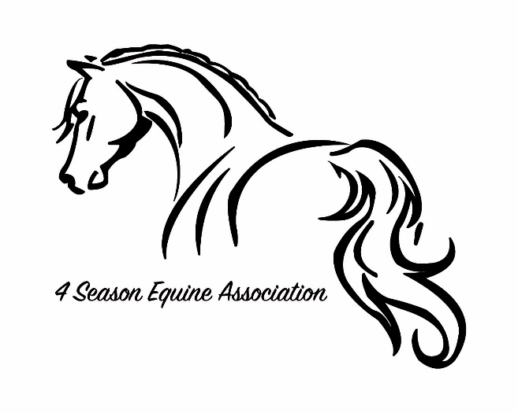
2020 Membership Application

$30 for ALL Memberships
Adult voting member information:
Name: ____________________________ Birthdate: _______________________
Address: ___________________________ Email: ___________________________
City: _______________________________ Phone: __________________________
Zip: _______________________________
Other Family Members:
Name: ____________________________ Birthdate: ______________________
Name: ____________________________ Birthdate: ______________________
Name: ____________________________ Birthdate: ______________________
Equine Interests (circle all that interest you):
Showing Trail Riding Volunteerism Breeding Clinics
Training Boarding Member events Banquets Awards
Tell us about your horses:
Name: ________________________ Age:________ Sex: _____ Breed: _____________________
Name: ________________________ Age:________ Sex: _____ Breed: _____________________
Name: ________________________ Age:________ Sex: _____ Breed: _____________________
Name: ________________________ Age:________ Sex: _____ Breed: _____________________
By submitting this membership application, you agree to hold the 4 Season Equine Association, its members and their families, committees, sponsors and assigns, harmless for any legal claims relating to physical, mental, or financial incidents or injury in association with 4 Season Equine Association sponsored events. In addition, signing this application constitutes that you have agreed to all 4 Seasons Equine Association rules and bylaws.

________________________________________________________________
Adult Voting Member signature and Date
Warning: Under the Michigan Equine activity liability act, an equine professional is not liable for an injury to or death of a participant in an equine activity resulting from an inherent risk of the equine activity. 4 Season Equine Association. Its officers/board members, volunteers & show staff or any event host location is not responsible for injury.

Please make checks payable to
“4 Season Equine Association”
Applications and checks can
be mailed to Kelly Leohnard
10349 Blackman Rd, Kingsley 49649.

