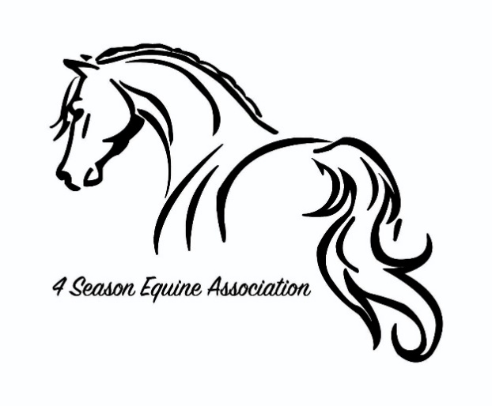
2023
Membership Form
Please Print
Name:
Birthdate if under age 19:
Street Address:
City: Zip Code:
Email address:
Phone:

$20.00 Membership Fee per individual. Please fill out one form per person.

Name/ Requested Back Tag Number
Please indicate preferred method of communication: email, text or snail mail.
I agree to the rules and regulations of the 4 Season Equine Association.
Signature: Date:
(If under 18 signatures of parent or guardian)
Mail forms and Checks to: Tina Weinrick Make Checks payable to:
1217 Mill Rd. 4sea
Kingsley, MI. 49649

Warning: Under Michigan Equine activity liability act, an equine professional is not liable for an injury to or death of a participant in an equine activity resulting from an inherent risk of the equine activity. 4 Season Equine Association, its officers/board member, volunteers & show staff or any event host location is not responsible for injury.

For office use only:
Date received: | Received by:

